Load OAR

An OAR is a Object Archive - a complete region with content, terrain and scripts. You click the Menu to load a Free OAR from the Outworldz, and a list of free OARs appears:

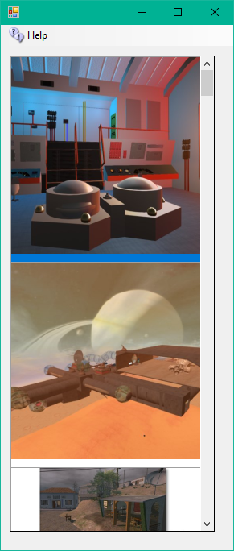

The name, file size, and the credits/license for the OAR appears when you hover your mouse over the photo.

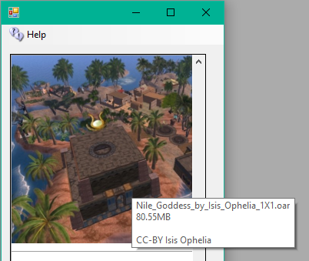

Clicking any photo brings up a region chooser box:

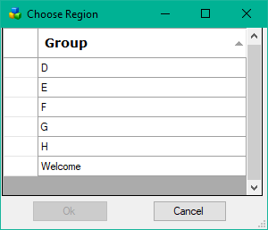

Select the Region you wish to load, and click OK. you can also double-click the region.

Click a Blue section to choose which section of this Var Region to put this OAR in.
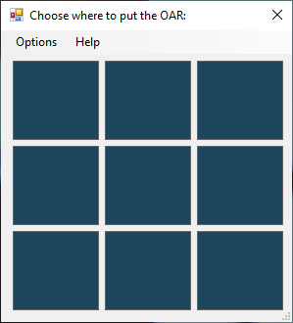

Options:

-merge

Specify to merge the contents of the reading OAR with the existing contents in the region.

--displacement

Specify a displacement that is added to all data as it is added to the destination region. The displacement MUST be specified as "<x,y,z>". So, for instance, to load an OAR from a 256x256 region into the middle of a larger 512x512 region, the parameter would be --displacement "<128,128,0>". Note that you can specify a "Z" displacement which will move the objects up or down. Thus --displacement "<0,0,1000>" will put all the OAR's objects up high for a sky box.

The displacement is also applied to the terrain if it is included. The 'z' component is added to the terrain's heights.

--force-terrain

Force terrain loading on --merge. Normally, --merge does not overwrite the existing region's terrain.

--force-parcels

Force parcel loading on --merge. Normally, --merge does not overwrite the existing region's parcel data.

--default-user "<first-name> <last-name>"

Instead of setting object ownership to the estate owner, assign it to the named user. This only applies to objects that have UUIDs that do not match any user account in the receiving grid's installation. There is currently no option that will force a change of owner for all loaded objects no matter whether they match a user in the receiving installation. One workaround to achieve this would be to save the OAR with the --publish "save oar" option to strip owner information and then reload it.

Links:

http://opensimulator.org/wiki/Load_Oar_0.9.0%2B

